Name: Fatima Adel Aljunaibi

Professional Development Plan
(What do YOU need to work on in order to grow professionally?)
- I need to learn more about managing the classroom and getting the students attention.

- Choose and describe an aspect from a teaching competency that you need to work on (Goal)
- I need to get more experience about the "classroom managing" to help me to get organized with the children. That is will save the time.
- Describe what you will do to help achieve your goal (Strategies Used)
- Encourages students for example say for them good job, look to Ahmad he is listening to the teacher and remind them about rules.
Grade Level:  GK2 |  | Subject:  Numeracy |  | Learning Outcome (ADEC code and words):  K2NS5: Identify familiar and patterned arrangements for 1-5 and recognize these arrangements by sight for 1-3/ Identify familiar and patterned arrangements for 1-3.
Resources (what materials/equipment will you and the students use? Be specific) |  |  | Preparation (what do you need to make or check before class?)  - Identify familiar and patterned arrangements for 1-5.  - Recognize these arrangements by sight for 1-3.  - Identify familiar and patterned arrangements for 1-3.
Whole | Introduction (warmer activity + teacher active engagement)  - How many days are in a week? 7 days (Show me in your hand)  What is the day today? If today is Tuesday, What will be the day tomorrow? What was the day yesterday?  - Song about the numbers 1- 20.  - Relate the numbers with the child's life by asking questions.  - How many sisters do you have? (Show me in your hand).
Independent Experience (small group activity 1)
Number Writing Activity. Sand Tray Game.
- I picked out a lovely stick to use as our mark making tool as it’s always fun to have a novel way of writing and making patterns!

- Then the kids chose one number leaf at a time to practise forming the letter shape in the sensory writing tray.

- Because the surface is large, the movement is big while writing and that is a really good way to begin trying to make formal number shapes. It focuses the movement from the shoulder and elbow and makes it a gross motor action rather than a fiddly and awkward fine motor one
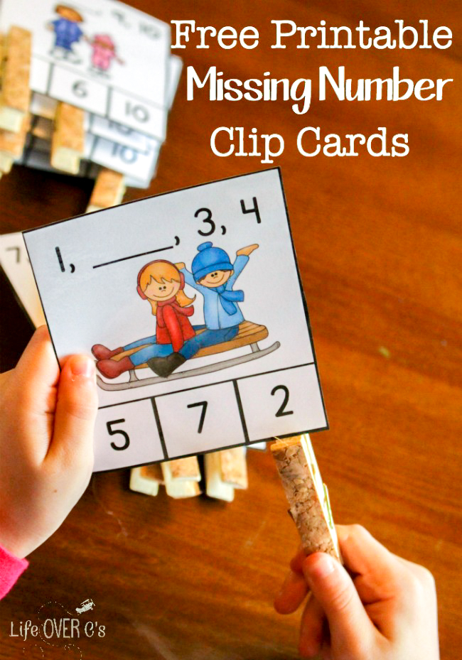
Independent Experience (small group activity 2)
WINTER MISSING NUMBER CLIP CARDS
- It’s easy to count numbers in complete order, but it’s a bit more of a challenge to figure when a number is missing.
- Kids can mark the correct answer with their clothespin for some work on fine motor skills while they are working on their math skills
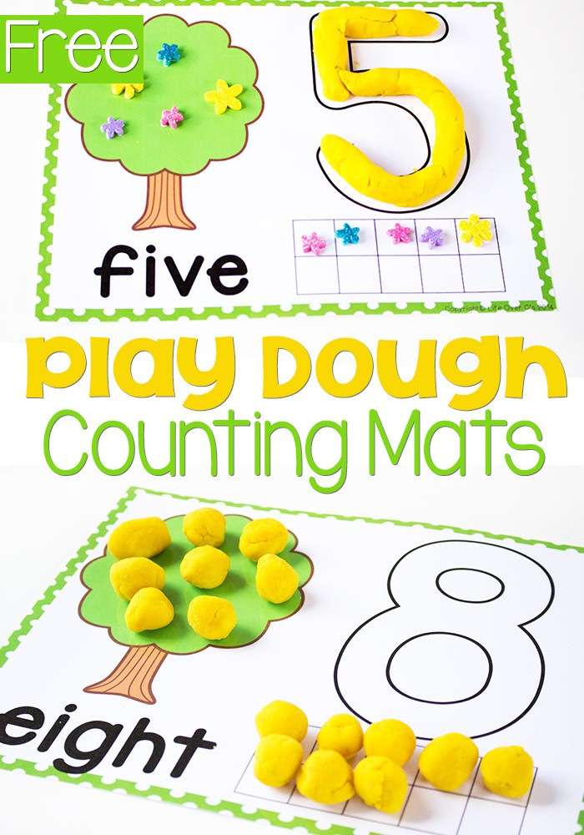
Independent Experience (small group activity 3)
Number Play Dough
- These play dough number mats can be used to represent different stages of a tree as well. Or you could put apples, peaches, pears, and cherries.
- Let your child’s imagination run wild!

Closing | - Some student will like to present for other student what did they do in the center. I will thank the students and engage them.
Assessment
- Taking pictures of students work.
- Asking questions

