Name: Fatima Adel Aljunaibi

Professional Development Plan
(What do YOU need to work on in order to grow professionally?)
- I need to learn more about managing the classroom and getting the students attention.

- Choose and describe an aspect from a teaching competency that you need to work on (Goal)
- I need to get more experience about the "classroom managing" to help me to get organized with the children. That is will save the time.
- Describe what you will do to help achieve your goal (Strategies Used)
- Encourages students for example say for them good job, look to Ahmad he is listening to the teacher and remind them about rules.

- Describe how you can tell if you’re achieving your goal (Evidence)
Let the students explain what they did in the centres. Also, Show their work for the others.

Grade Level:  GK2 |  | Subject:  English Literacy |  | Learning Outcome (ADEC code and words):  KLPA3: Listen to and identify phonemes in words/ Listen to and say individual phonemes in words through reading words slowly/ Listen to individual phonemes in words
Resources (what materials/equipment will you and the students use? Be specific)  - Activity 1  - Clothespins  - Baskets  - Vocabulary cards  - Activity 2  - Box of Sand  - Different letters  - Activity 3  - Paint  - Paper  - Googly eyes |  |  | Preparation (what do you need to make or check before class?)  - Know and identify the learning objectives for the learners.  - Link the activities with the outcome and make.  - Prepare different ways to explain the lesson.  - Key vocabulary  - Dinosaur  - Dog  - Duck  - Drum  - Donut  - Doll
Whole | Introduction (warmer activity + teacher active engagement)  - Song of sounds  - I will ask the children about the letter D and the sound of letter D.  “What is this letter? What sound does it make? Or What sound D makes?  - http://www.abcmouse.com/ http://www.starfall.com “ Can you give me word start with letter D?
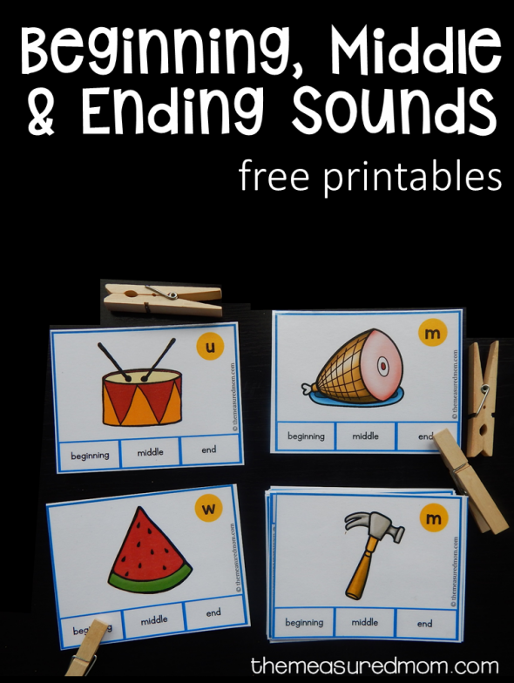
Independent Experience (small group activity 1)
- This activity will help the learners in the clip cards words supports the common core standards for phonics and word recognition, Print concepts, conventions of standard English, and vocabulary acquisition and Use.
- Learners read the cards words and clip a clothespin on the correct picture.

Independent Experience (small group activity 2)
- This activity will help the learners to identify D.
- Learners will identify and look for D's with different letters in the Salt Box.

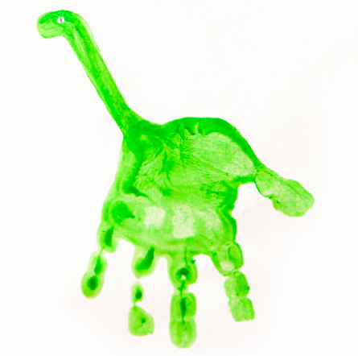
Independent Experience (small group activity 3)

Alphabet Handprint Art D is for Dinosaur
The child’s will paint their hand with the paint color for the dinosaur. They can get creative and choose what color that they want their dinosaur to be.

- Using the same colored marker or pencil, draw a long neck on the dinosaur.

Closing | - Some student will like to present for other student what did they do in the center. I will thank the students and engage them.  - http://www.abcmouse.com/
Assessment
- Tiny me.
- Formative assessment chart.
- If I have yes I understand student, I will make sure that they understand by asking them a question that match the outcome and the concept.

