Name: Fatima Adel Aljunaibi

Professional Development Plan
(What do YOU need to work on in order to grow professionally?)
- I need to learn more about managing the classroom and getting the students attention.

- Choose and describe an aspect from a teaching competency that you need to work on (Goal)
- I need to get more experience about the "classroom managing" to help me to get organized with the children. That is will save the time.
- Describe what you will do to help achieve your goal (Strategies Used)
- Encourages students for example say for them good job, look to Ahmad he is listening to the teacher and remind them about rules.
Grade Level:  GK2 |  | Subject:  Science |  | Learning Outcome (ADEC code and words):  KES2: Describe characteristics of weather/ Identify characteristics of weather/ Illustrate characteristics of weather
Resources (what materials/equipment will you and the students use? Be specific)  - Songs about the weather  - Pictures  - Baskets  - Vocabulary cards  - Materials needed activity 1  - Paper  - Construction paper cut in umbrella shapes  - Glue  - Sticks  - Pencil  Materials needed activity 2  - Purple  - Glue/tape  - Googly eyes  - Markers  - Colours |  |  | Preparation (what do you need to make or check before class?)  - Know and identify the learning objectives for the learners.  - Link the activities with the outcome and make.  - Prepare different ways to explain the lesson.  - Key vocabulary  - Sun – Sunny  - Rain – Raining  - Clouds – Cloudy  - Snow – Snowing  - Umbrella
Whole  Time: 15 min | Introduction (warmer activity + teacher active engagement)  - Song about the weather  - Words Cards matching
Independent Experience (small group activity 1)
- Materials needed activity 1
- Paper
- Construction paper cut in umbrella shapes
- Glue
- Sticks
- Pencil
- Children will do
- Children will create their own umbrella.
- Children will writing the word umbrella”.

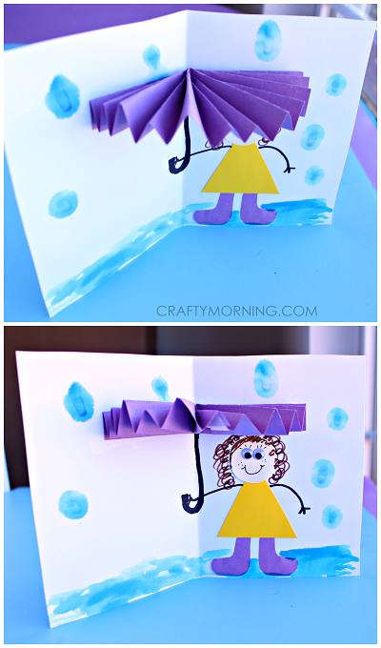
Independent Experience (small group activity 2)
“Umbrella Rainy Day Card for Kids”.

Materials needed:
- Purple
- Glue/tape
- Googly eyes
- Markers
- Colours
- Children will do
- Fold the colored paper back and forth until you get to the end.
- Pinch it together and then fold it in half.
- Tape the middle parts together and glue the middle bottom part.
- Lay it flat against a folded paper card and glue it down.
- Draw an umbrella handle with a black marker.
- Children will imagine that they are under the umbrella and they will draw their self.
(Michelle, 2015)

Independent Experience (small group activity 3)
Words Cards matching

- Children will do
- Children will identify the words with the pictures and then match it.

Closing  Time: 15 min | - Some student will like to present for other student what did they do in the center. I will thank the students and engage them.  - Song about the weather (Focus in the Sunny, Raining and Cloudy)
Assessment
- Taking pictures of students work.
- Asking questions

