Name: Fatima Adel Aljunaibi

Professional Development Plan
(What do YOU need to work on in order to grow professionally?)
- I need to learn more about managing the classroom and getting the students attention.

- Choose and describe an aspect from a teaching competency that you need to work on (Goal)
- I need to get more experience about the "classroom managing" to help me to get organized with the children. That is will save the time.
- Describe what you will do to help achieve your goal (Strategies Used)
- Encourages students for example say for them good job, look to Ahmad he is listening to the teacher and remind them about rules.

- Describe how you can tell if you’re achieving your goal (Evidence)
Let the students explain what they did in the centres. Also, Show their work for the others.

Grade Level:  GK2 |  | Subject:  English Literacy |  | Learning Outcome (ADEC code and words):  KLPA3: Listen to and identify phonemes in words/ Listen to and say individual phonemes in words through reading words slowly/ Listen to individual phonemes in words
Resources (what materials/equipment will you and the students use? Be specific)  Link:  “Today, while you’re at your learning centers, you need to remember…”  - Good Siting  - Quiet mouth  - If you need help Raise your hand |  |  | Preparation (what do you need to make or check before class?)  - Know and identify the learning objectives for the learners.  - Link the activities with the outcome and make.  - Prepare different ways to explain the lesson.  - Key vocabulary  Fish  Flower  Frog  Fox  Flag
Whole | Introduction (warmer activity + teacher active engagement)  - Song of sounds  - Song about the letters.  - Relate the focus letter in the child's life by asking questions.  - Let's see who has F in their name?  - Smartboard focus on the letter F  - I will ask the children about the letter F and the sound of letter F.  “What is this letter? What sound does it make? Or What sound F makes?  - http://www.abcmouse.com/ http://www.starfall.com “ Can you give me word start with letter F?
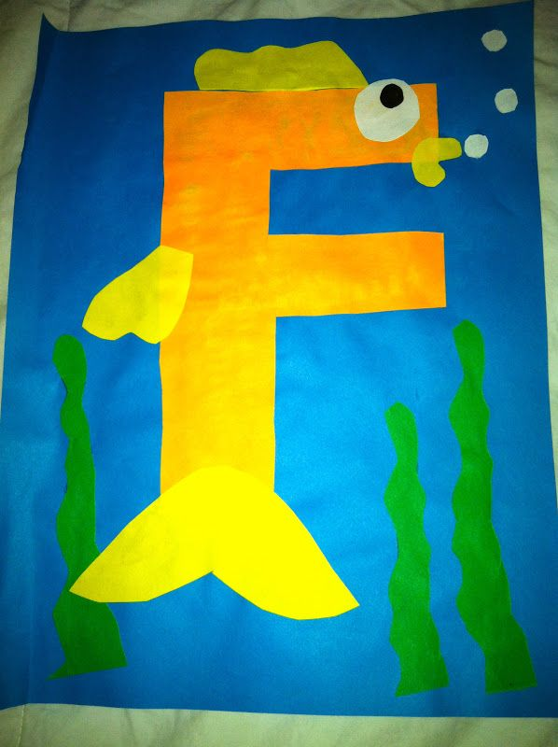
Independent Experience (small group activity 1)
Learning Center 1:
F is for Fish

Teacher will do:
- Cut the white papers in different shape.
- Explain the activity for the students
Student will do:
- The student will stick the papers.
- Then the students will color it and make their fish.
Question:
- F for what?
- What this letter?
- Can you say F?
- What is this color?

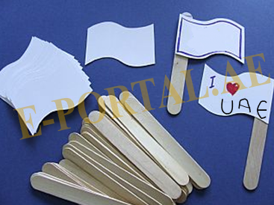
Independent Experience (small group activity 2)
AE Flag
Teacher will do:
- The teacher give the students stick and paper.

Student will do:
- The students will write, " I then drew the heart UAE".

- Color the paper.
Question:
- Do you know the color of the UAE flag?
- Where will we put red color? In this side?
- What is this color?

Independent Experience (small group activity 3)

F is for Frog

Teacher will do:
- Cut the green papers in letter F and .
- Help the students while they do the activity.
Student will do:
- Glue the F to the paper.
- Add round circles to the letter F
- Add the black stickers (or glue the black circles) to the larger white circles and attach them to the top of the F.
- Attach the frog legs.
Question:
- F for what?
- What this letter?
- Can you say F?
- What is this color?

Closing | - Some student will like to present for other student what did they do in the center. I will thank the students and engage them.  - http://www.abcmouse.com/
Assessment
- Tiny me.
- Formative assessment chart.
- If I have yes I understand student, I will make sure that they understand by asking them a question that match the outcome and the concept.

