Lesson Plan Template
Name: Fatima Adel Aljunaibi
Professional Development Plan
(What do YOU need to work on in order to grow professionally?)

- Choose and describe an aspect from a teaching competency that you need to work on (Goal)
- I need to get more experience about the "classroom managing" focus on manages the centers and the closing. That will help me to get organized with the children.
- Describe what you will do to help achieve your goal (Strategies Used)
- Encourages students for example say for them good job, look to Ahmad he is listening to the teacher and remind them about rules.
- Describe how you can tell if you’re achieving your goal (Evidence)
- Let the students explain what they did in the centres. Also, Show their work for the others.
Grade Level:  KG2 |  | Subject:  Literacy |  | Learning Outcome (ADEC code and words):  KLPA3: Listen to and identify phonemes in words/ Listen to and say individual phonemes in words through reading words slowly/ Listen to individual phonemes in words  KLLK2: Recognize sequence of letters in words  KLTC9: Listen respond to simple verbal questions; ask questions related to a topic.  Differentiation: Students will put letters to gather to create words and then they will decided which one is first second, third.  High: Students will put letters to gather to create words and then they will decided which one is first second, third.  Low: students will circle specific letters that the teacher mentioned and they count the sequence of order the letter is in that word.
Resources (what materials/equipment will you and the students use? Be specific)  - Art Activity (student will make Stork bird)  - Scissors  - Colors  - Glue  - Marker |  |  | Preparation (what do you need to make or check before class?)  Make sure the smart board is work  The activates are ready  Key vocabulary  - The jungle  - Mouse  - Elephant  - Tiger  - Hippopotamus  - Monkey  - Stork bird  Letters and Sounds:  Review all letters  Sight words:  We-so-she-here-he-be-with-go-am-up-that.
Whole  Time: 10-15 min | Introduction (warmer activity + teacher introduction/demonstration of small group activities)  Daily routine  - Morning message  - Attendance  - Classroom rules  - Song of sounds song  - Learning outcomes  - Introduce the theme  - Success criteria  - Center rotation  Teacher will review all the letters and their sounds play the song of sounds song. Review the letters by using ABCYA website review the sight words.
Small  Time: 10-15 min | Active Engagement (group working with the teacher)  Introduce the theme, and it will be about the jungle animals by reading for the students a story “The selfish crocodile.”  - What sound does letter C make?" What sound do we hear in the beginning of word crocodile?  - How many sounds do you hear in the word Tiger? What is the sound you heard first? /T/. The sound you heard next? /g/. The last sound is /r/.  - You need to think about how many sounds you heard in the word?  - What sound you hear first? Next? Last?
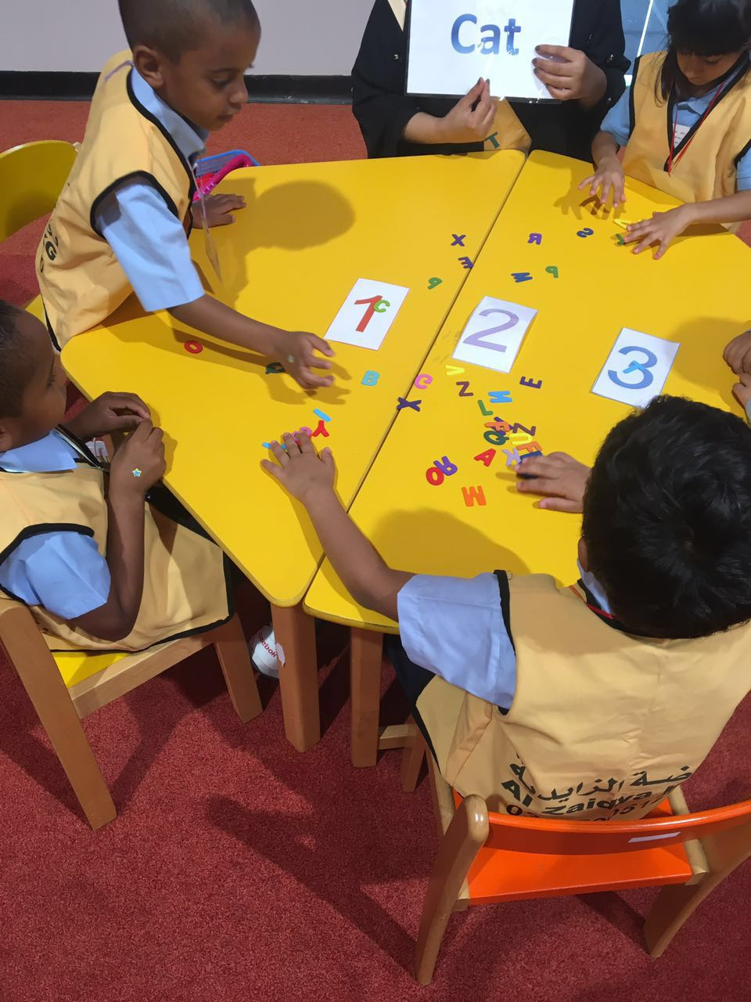
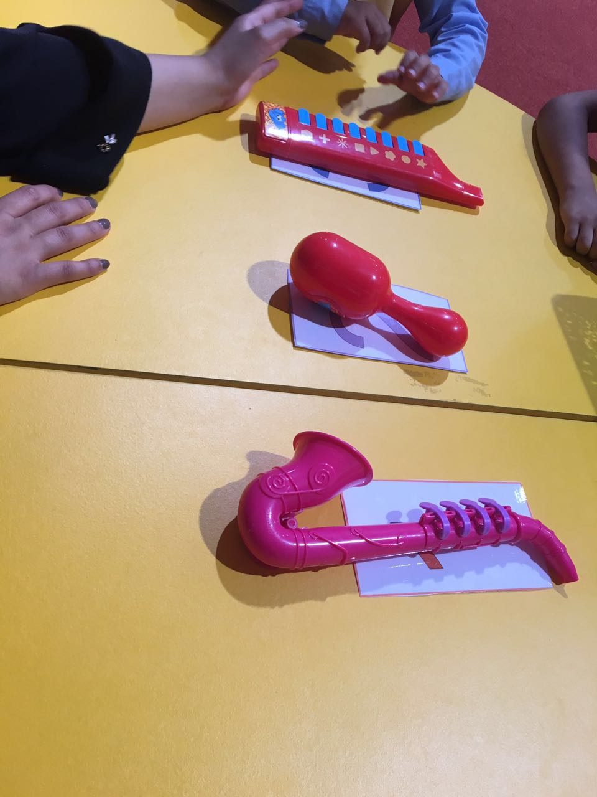
Independent Experience (small group activity 1)
Put three different musical instruments in front children. Children will think about sequences of sound. Then they will guess which musical instrument made the sound first, second and third.

Show children pictures of objects consisting of three phonemes. Then they will choose letters from basket and match the first letter to the first sound of the musical instrument.

Independent Experience (small group activity 2)
Independent Experience (small group activity3)

Small Focus: KLPA3
High-level students will play bingo matching the picture to the word. They will focus on the beginning sounds and some blends.
Mid level students will play bingo-matching pictures to the initial letter sounds
Lower level students will match the picture to a picture and tell me the sound it makes.
Photo name puzzle
- First, I will print students picture.
- I will use a permanent marker to write student name, spacing it out over the length of the photo. Than cut the photo into vertical strips. Puzzle complete!
- After that, the students will organize the sequence of letters in their name.
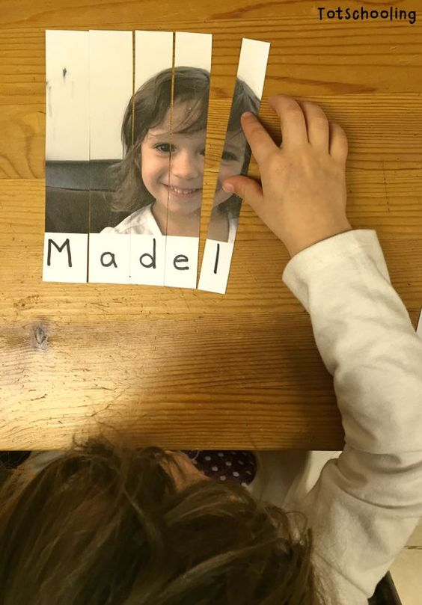 _{(PHOTO NAME PUZZLE, 2015)}
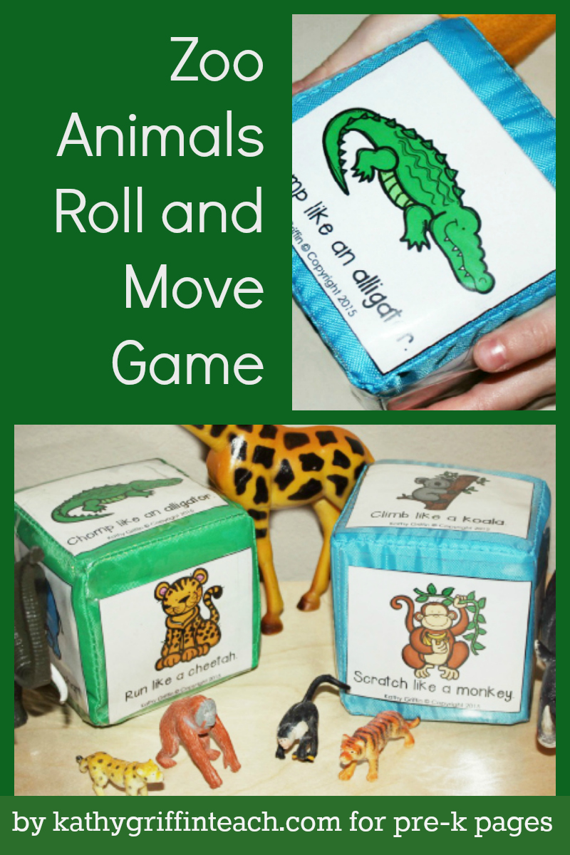
Independent Experience (small group activity 4)
(Editor)
Earning Opportunities:
This game helps children build skills in different ways
- Listening
- Following Directions
- Building Vocabulary
In addition to these skills, children can develop social skills when they play group games together. Use Roll and Move with the jungle animals with a small group of children. This movement game encourages all kinds of bending, crawling, hopping, and stretching.

Materials Needed
- Soft Pocket Die
- Zoo Animal Roll and Move Printable
- Scissors
- Prepare the cube: Print the cards and cut them apart. Slide the cards in the die.

Directions for Group Learning “ We can use music I like move it”
- Roll the die.
- Name the animal.
- Read the sentence.
- Children move like the animal.
- Pass the die to a child.
- Child rolls the die.
- Child names the animal.
- Child reads the sentence.
- All children move like the animal.
- Repeat.
After the Game
- Brainstorm and record a list of other zoo animals.
- Ask the children how these animals move.

Closing  Time: 5-10 10 min | When they finish their activity, teacher I will ask them what did they do in the centre?  Each Student will answer the question, and say what did he\she learn today.
Assessment
Taking pictures of students work.
High Order Thinking Skills and Questions

_{Bibliography}
Editor. (n.d.). pre-kpages. Retrieved from ANIMALS ROLL AND MOVE GAME.
PHOTO NAME PUZZLE. (2015, 2 19). Retrieved from totschooling: http://www.totschooling.net/2015/02/photo-name-puzzle.html

