Name: Fatima Adel Aljunaibi

Professional Development Plan
(What do YOU need to work on in order to grow professionally?)
- I need to learn more about managing the classroom and getting the students attention.

- Choose and describe an aspect from a teaching competency that you need to work on (Goal)
- I need to get more experience about the "classroom managing" to help me to get organized with the children. That is will save the time.
- Describe what you will do to help achieve your goal (Strategies Used)
- Encourages students for example say for them good job, look to Ahmad he is listening to the teacher and remind them about rules.
Grade Level:  GK2 |  | Subject:  Numeracy |  | Learning Outcome (ADEC code and words):  K2NS2: State the backwards number sequence from 1-20 in Arabic and English/ State the backwards number sequence from 1-10 in Arabic and English/ State the backwards number sequence from 1-5 in Arabic and English  K2MDM1: Compare and describe the length of two objects/ Create long and short objects in exploration and play/ Identify long and short objects in exploration and play.
Resources (what materials/equipment will you and the students use? Be specific)  - Different objects (for long& short) |  |  | Preparation (what do you need to make or check before class?)  - Identify long and short objects in exploration and play.  - Prepare different ways to explain the lesson.  - Have students measure several classroom objects using manipulatives and then count how many.  - Key vocabulary  - Long  - Short
Whole | Introduction (warmer activity + teacher active engagement)  - How many days are in a week? 7 days (Show me in your hand)  What is the day today? If today is Wednesday, What will be the day tomorrow? What was the day yesterday?  - Song about the numbers 1- 20.  - Relate the numbers with the child's life by asking questions.  - How many sisters do you have? (Show me in your hand).  - Website http://pbskids.org/
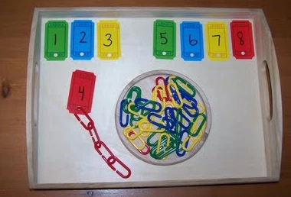
Independent Experience (small group activity 1)
Learning Center Resources or Materials
- Ticket outline.
- Some paper clips.
Teacher will do:
- Laminator a ticket then hole punch to paperclips.
- Explain the activity for the students and how to you love to use the paper.
Student will do:
- Student will write the number in the tickets.
- The students like to yours the paper clip and match it with the number.

Independent Experience (small group activity 2)
Learning Center Resources or Materials
1. Shoes
2. Cubes
3. Marker
4. Scissors
Teacher will do:
- Give the each children paper and a marker.
- Tell the children to take off their shoes.
Children will do:
- Children will take off their shoes.
- The children will put her or his then they will draw it in their paper.
- The children will cut the paper.
- The children will use the cube to measure their shoe. Then they will compare with each other and see who have the tallest.
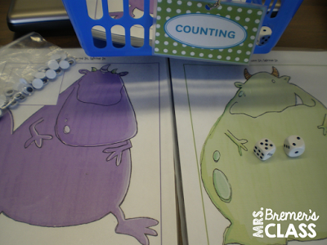
Independent Experience (small group activity 3)
Learning Center Resources or Materials
- Monster math
- Eyes
- Glue
Teacher will do:
- Each student takes a monster math.
- The teacher will you play with the students and show them the activity.
Student will do:
- On their turn they roll the dice.
- Add the numbers of eyes that giving in the dice.

This activity is appropriate for all levels:
- Mastered: I will give them this activity with the number (1-20) and students will stick the eyes.
- Developing: I will give them this activity with the number (15) and students will stick the eyes.
- Emerging: I will give them this activity with the number (5-10) and students will stick the eyes.

Closing | - Some student will like to present for other student what did they do in the center. I will thank the students and engage them.
Assessment
- Taking pictures of students work.
- Asking questions

