Name: Fatima Adel Aljunaibi
Professional Development Plan
(What do YOU need to work on in order to grow professionally?)

- Choose and describe an aspect from a teaching competency that you need to work on (Goal)
- I need to get more experience about the "classroom managing" focus on manages the centers and the closing. That will help me to get organized with the children.
- Describe what you will do to help achieve your goal (Strategies Used)
- Encourages students for example say for them good job, look to Ahmad he is listening to the teacher and remind them about rules.
- Describe how you can tell if you’re achieving your goal (Evidence)
- Let the students explain what they did in the centres. Also, Show their work for the others.
Grade Level:  KG2A |  | Subject:  Literacy |  | Learning Outcome (ADEC code and words):  KLTC7: Give a simple message to another student, a known or unknown adult using polite terms  KWC6: Use capital letters for names  Letters and Sounds:  Review all letters
Resources (what materials/equipment will you and the students use? Be specific)  - A child-friendly magazine  - Scissors  - Glue stick |  |  | Preparation (what do you need to make or check before class?)  Make sure the smart board is work  The activates are ready  Key vocabulary:  Head, hand, face, finger, eyes, body, ears, toes, shoulders, nose, leg, knees arm  Sight words:  we-so-she-here-he-be-with-go-am-up-that-yellow-five-six
Whole  Time: 10-15 min | Introduction (warmer activity + teacher introduction/demonstration of small group activities)  - Morning message  - Attendance  - Classroom rules  - Song of sounds song  - Learning outcomes  - Introduce the theme
Small  Time: 15 min | Active Engagement (group working with the teacher)  Smart board “ Students write their names
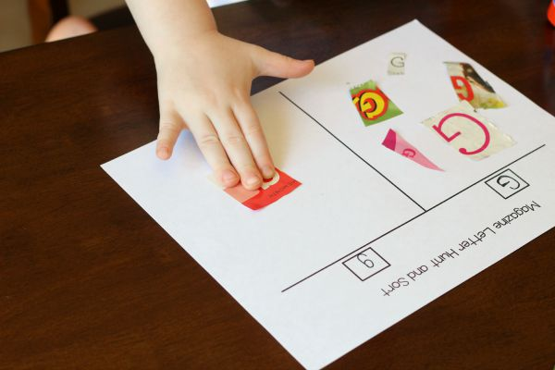
Independent Experience (small group activity 1)
- I will instruct the students to search through the magazine to find the letters, cut them out and then glue them to the correct side of the printable.
- I will the students pick a letter to have work on. Then I wrote the letter “A” in the box on one side of the sheet and “a” in the box on the other side of the sheet. Also, they could work on two different letters.
(Magazine Letter Hunt and Sort Activity, 2015)
Independent Experience (small group activity 2)
Letters and Sounds:
Alphabet Hats: Review all letters

Students will do:
- Colour the upper and lower case letter
- Colour the letter pictures (great for letter recognition and building vocabulary)
- Trace the picture words (optional).
- Now cut apart on the dotted lines and tape together to make a crown

(Alphabet Hats)
Independent Experience (small group activity 3)
Let the students create a story by using their names.
Closing  Time: 5-10 min | When they finish their activity, teacher I will ask them what did they do in the centre?  Each Student will answer the question, and say what did he\she learn today.
Assessment: High Order Thinking Skills and Questions

